# CS 255 System Design Document Template

## UML Diagrams

### UML Use Case Diagram

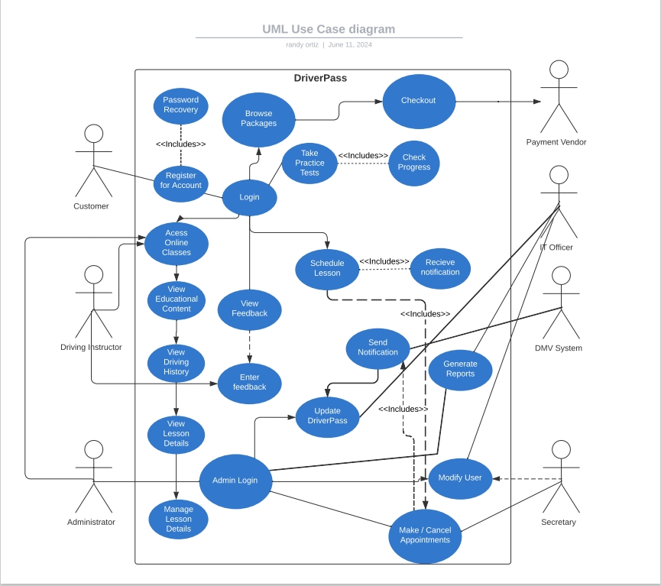

### UML Activity Diagrams

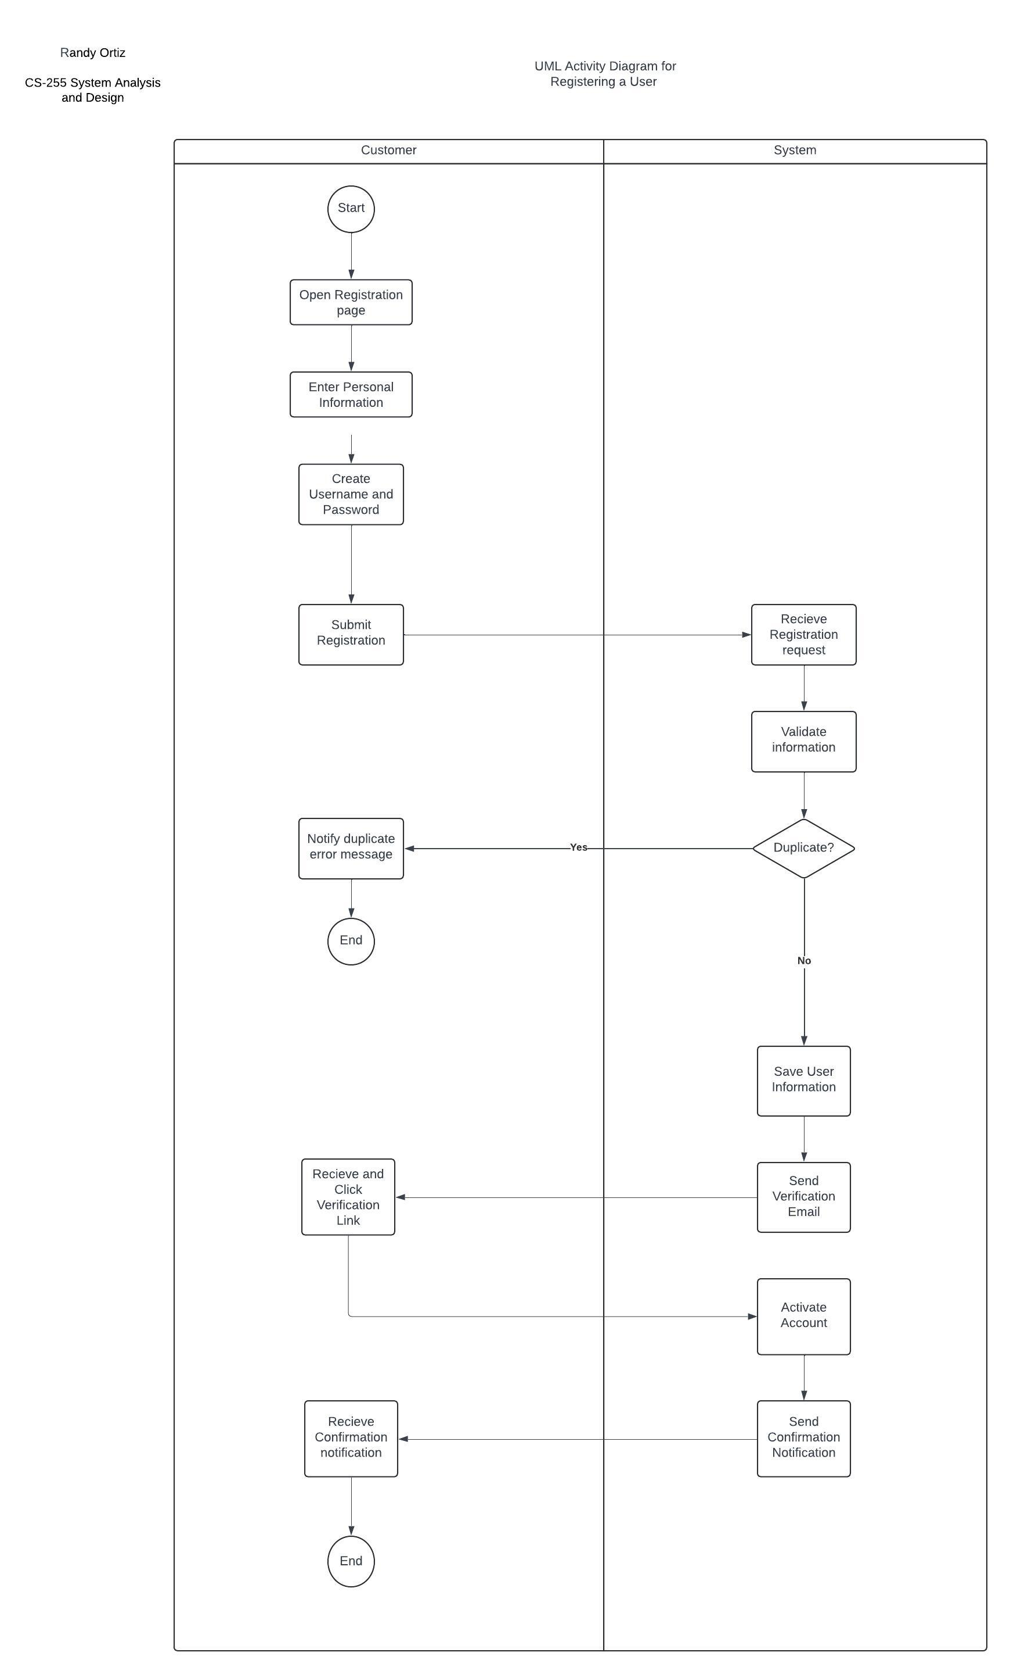

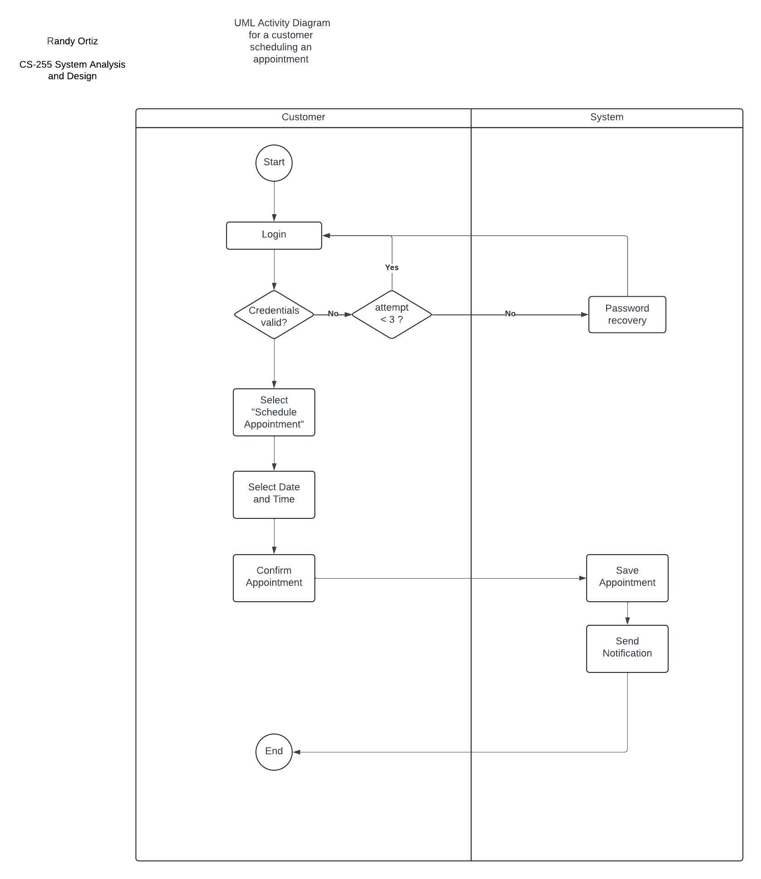

### UML Sequence Diagram

### UML Class Diagram

## Technical Requirements

**Hardware Requirements**

For the server hardware, a quad-core processor or better, such as Intel Xeon or AMD Ryzen, is required to handle multiple simultaneous user requests and ensure smooth operation. A minimum of 16 GB RAM is necessary, with 32 GB recommended for better performance. An SSD with at least 1TB capacity is essential for quick data retrieval and storage. Additionally, a high-speed network interface is needed for efficient data handling.

**Software Requirements**

The server should run on Linux or Windows Server, while client machines should operate on Windows 10/11, macOS, or Linux to ensure compatibility and stability. For database management, MySQL is preferred for reliable relational database management.

Development tools include an IDE such as Eclipse or Visual Studio Code to facilitate efficient coding, debugging, and testing. Backend development will utilize languages like Java or Python and frontend development will employ HTML and JavaScript.

**Tools**

Version control is crucial for tracking code changes and collaboration, with Git alongside GitHub or GitLab being the preferred tools. Project management should be handled using Jira to plan, track, and manage project tasks and progress.

**Infrastructure**

A secure internal network with firewall protection is necessary to safeguard the system from unauthorized access. High-speed internet connectivity is required for both server and client machines to ensure fast and reliable access to the DriverPass system.

Security measures include multi-factor authentication for user logins to enhance security. Regular data backups, either cloud-based or on-premises, are essential for data recovery in case of system failures. For scalability, cloud services can provide scalable infrastructure and storage solutions to handle increased load and storage requirements as the user base grows.